10 Tips to Drive Volunteer Firefighter & EMS Recruitment in 2019

Recruiting new volunteers isn’t easy, but it’s not impossible. There are two big challenges we’ve found most departments face with recruitment — marketing to find the best possible candidates and tracking them through the process.
Here are a few quick tips to get your recruitment efforts moving forward in 2019 and beyond:

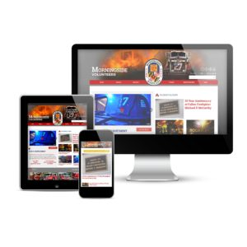1. Maximize Your Website for Recruitment
Over the last few years, departments have relied more on their social media presence to drive information about their department. But for potential volunteer recruits, you need a robust website that is packed with information on the how, why and what of becoming a volunteer firefighter, EMT or support/auxiliary member.
We’re not talking just one page of your website with a few sentences and a way to contact you. Your department website should include detailed information, including why someone would want to join, what are the benefits of being a volunteer, what training and equipment is provided/required and provide answers to the frequently asked questions a prospective volunteer may have.

2. Find Your Recruitment Prospects on Facebook & Instagram
Once you’ve got a section of your web site dedicated to recruitment, Facebook is among the easiest ways to target potential volunteers with advertising messages about your department, drive them to your web site and collect those recruitment form leads. As a bonus, you can also push these campaigns to Instagram.
You can budget as little as $25/month and get an immediate impact from recruitment campaigns on Facebook. You can target by specific demographic, age ranges, those interested in volunteering and causes, and more. Then, you can “boost” posts on Facebook (such as status updates, videos, and photos) or create unique campaigns targeting your selected demographics.

3. Use the FREE Recruitment Resources from the NVFC
The National Volunteer Fire Council’s Make Me a Firefighter program is a great resource for U.S.-based volunteer fire and EMS departments to get a slew of free resources and marketing for recruitment efforts.
Signing up to create your department’s free profile is easy — just head to portal.nvfc.org now. Once registered, you’ll also have access to invitations, postcards, posters, social media images and more — all of which you can customize to meet your department’s specific needs. Plus you can download and embed videos for use in your own recruitment marketing efforts! It’s all free from the NVFC.

4. Apply for a SAFER Grant
With an expected extension of the FEMA SAFER (Staffing for Adequate Fire & Emergency Response) grants for up to six years (currently pending Senate approval at the time of this post), now is a great time to start looking at ways your department can benefit from this program.
You can use SAFER funds in the Recruitment & Retention category to fund recruitment marketing programs, member progression incentives, pay for PPE for new recruits and more.
Application dates for the FY17 and FY18 programs are likely to be announced soon. The application period typically lasts about a month. Be sure your department is prepared to apply.

5. Are You a 501(c)(3)? Leverage Google for Non-Profit Programs
If your department is (or can become) a qualified as a 501(c)(3) nonprofit organization, you can qualify for some amazing benefits from the Google for Non Profitsprogram, including $10,000/month in search advertising — you can use that for recruitment, fundraising, event promotions and more. Plus, you’ll get unlimited free email accounts for your organization, Google Drive storage, shared calendars, YouTube enhancements and much more. It’s just a few steps to sign up and a big value to any qualifying non-profit.

6. Connect for Local TV & Radio Advertising
Many local television and radio stations (as well as other media outlets) have programs in place to support local non-profit and community organizations. This may include the opportunity for you to secure free advertising for your recruitment efforts. Use these ads to drive prospective recruits to a specific website address on your website (such as YourFD.com/join or YourFD.com/volunteer) where you can quickly let prospective volunteers know about your opportunities and collect their information. Get started by contacting the main number as your local media outlets and ask them who the appropriate contact is within their company for community relations and public service announcements.

7. Host Scheduled Recruitment Events
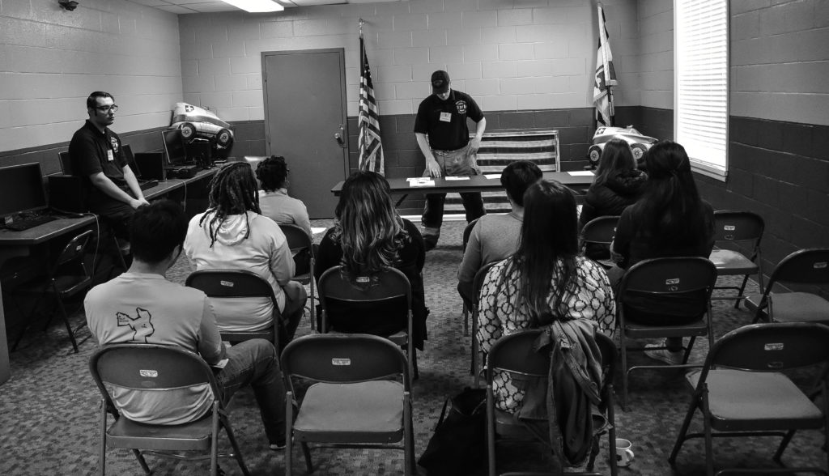
Morningside VFD (Maryland) Recruitment Event – 2017
Once you’ve identified the vehicles to drive your recruitment prospects — now you need to get them in the door to get the process started. Whether your application process is basic (just a firehouse visit) or advanced (background checks, physicals, etc), the first step should include an initial visit to the station. During these events, you can:
- Provide yours of your facility and equipment.
- Have prospective volunteers meet other members.
- Go over all steps of the process — from the initial visit through to their first year or two of membership.
- Be exceptionally clear of the time commitment and other requirements — this is your opportunity to identify the best possible volunteer prospects, including weeding out those who cannot meet your needs and requirements. Recruitment is more about quality than quantity.
Having additional materials such as a Prospective Member Guide, application packets and plenty of time to answer all questions is also key for this first visit. From there they can schedule ride along(s) or whatever the next step is in your process. Setting a fixed schedule (once a month, once a quarter, etc.) and posting those dates in advance and regularly on your website, social media, signs in front of station and more, will not only help recruits know when to come, but make it easier for your internal membership team to coordinate.

8. Videos Beyond Just Lights and Sirens
Every firehouse loves doing a year-end video showing all the fires, rescues and a slew of times responding down the road. Every firehouse. What makes your department different?
When it comes to recruitment, response videos only go so far. How do you separate yourself from the department the next town over or in the next county over where someone may want to volunteer? Better yet, how do you get their attention in the first place. Joining a volunteer firehouse is as much about the types (and volume) of calls you run as it is the people and culture your department has. Your people, your leadership, your fleet, your community engagement — all of that and more tell the story about why John Q Public should come to your station at all — let alone choose you over the station down the street. For someone coming in to your department with no experience, that is even more critical.
Think about creating a video that mixes in the responses with your people, your culture and mission — video on Facebook is the leading driver of volunteer recruitment interest among the departments we help at First Arriving. Whether its just a phone-snapped short video or professionally produced, making video a key part of your recruitment efforts is important.

9. Track Your Applicants Every Step of the Way
Now that you have qualified volunteer applicants, you want to be sure to track them through the entire recruitment process from the initial inquiry to becoming a member. There are many easy to use (and cost effective) solutions for accomplishing these objectives — plus they save a ton of valuable volunteer manpower time from manual processes.
- Automatically save leads from your website into Google docs or a CRM (Customer Relationship Management) platform — an easy to use platform that lets you track every step of your process, save standardized messages and forms and much more.
- Schedule appointments online for various steps of the process — the initial visit, background checks, pre-requisite training and more.
- Provide easy access for prospective recruits and internal R&R team members to a centralized recruitment calendar.
- Easily share recruitment workflow with multiple people in and out of the firehouse – less paper, more efficient time.
- Track your recruitment marketing efforts to get the best return on your budget.

10. Take the Next Steps As Prospects Become Members
One thing is for sure when you add new volunteers — there are a whole lot of new processes and information channels you’ll need to ensure you don’t lose sight of a few key areas:

DURING THE RECRUITMENT PROCESS
- Keep prospects engaged throughout the entire recruitment process with emails and phone calls
- Invite them to department events and ride along programs (if applicable)
- Provide them a clear point of contact (email, phone, etc.) if they have any questions, concerns or issues that arise during the recruitment process
- Don’t have any reservations about cutting off your recruitment marketing and programs to address any internal or process issues that arise. Take the time to ensure your organization is positively impacted by your membership growth — and protect it from negative unintended consequences.

ENSURE THE SUCCESS OF NEW — AND ALL — MEMBERS
Once a prospect becomes a full member of your organization, take the next steps in ensuring their success:
- Consider assigning them to a mentor or member who can help walk them through their first experience in the Fire/EMS service.
- Implement a tracking program to follow your member’s progress through the department — are they hitting the right marks? Where do they need help? Any number of programs can also help you track key certifications, schedule duty shifts, hold emergency contact information and more.
- Create a “New Member Guide” with your various checklists, progression information, copies of primary response maps, key forms and other critical details they’ll need to know as a member of your department. Solicit the “what” goes into that document from both your longstanding members (what do they wish new members knew sooner?) — and your newer members (what do they wish they had known when they first joined faster?)
- Create a members only private Facebook group where you can easily communicate special events, staffing needs, announcements and updates. Add an email list too.

Designed and Powered By:

