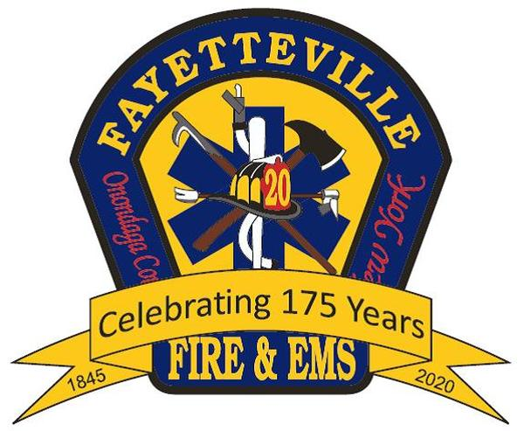
The Art of Speed Recruiting:
How to be Successful at In-Person Interactions

Introduction:
- Success starts with the right attitude: “Treat every public interaction as a public service, public education, public relations and a recruitment opportunity
- Word of mouth and personal referral are very effective means of motivating others to volunteer
- Master the art of “Speed Recruiting”
- Whether in a one-on-one or one-to-many interaction such as a trade/career path or open house, put your best image forward and be someone the prospect would want to volunteer with

Prepare to be Successful:
- Set a target/goal
- Know your audience
- Know your competition
  - Discuss why we shouldn’t have any competition for the right people
- Recruit the Right Recruiters

Create the Right Environment:
- Bringing the prospect into your environment (firehouse) vs. their environment (or neutral territory) enhances your chances of closing the sale
- Hype it up! Market your presence at the event long before the event
- Create inviting, attractive displays
  - Eliminate physical barriers but respect their personal space
- Make it Interactive:
  - Integrate Technology: Use a tablet/laptop for showing videos and capturing contact info online
    - Show how technology is integrated into everything we do: CAD, e-Pump Panels, thermal imaging, radios, app-based alerting, GIS, digital dashboards, etc.
  - Make it fun and interesting:
    - Bounce house (Kids=Parents=Prospects)
    - Create a simple challenge course/competition: Sledge sled, hose-roll bowling, hose line/nozzle target, gear donning, rock climbing wall (tech rescue), etc.
    - Demo e-Hydraulic tools, thermal imager, CPR to music, etc.
    - Include a photo-shoot backdrop, gear, radio/scanner
- Support your efforts with attractive, informative and motivating marketing materials
  - Prospective Member Guide
  - Brochure
  - Giveaway

Make the Pitch: Develop, rehearse and know your opening line (elevator speech):
- Keep it short and sweet – and then “shut-up and listen.” Demonstrate a genuine interest in the prospect.
- Never discount the value of a good reference. The person you’re speaking to may not be a prospective volunteer – but they may be a good influencer of others.
- Lead with the positives and benefits
  - Give examples of how you and others fit volunteering into their busy lifestyles
  - Tell the prospect what volunteering has meant/done for you
- Don’t downplay the requirements but emphasize why training is necessary and how it makes you a better volunteer and person
- Be prepared to answer questions

Close the Deal:
- Ask for the sale or move on
- Capture their data
- Ask if you can follow up with a phone call or email shortly

Follow-up and Follow-through:
- Follow up with prospects early and often
- Capture and keep their attention and engagement from inquiry through onboarding
- Collect and track data, learn from the experience, hone your pitch, improve/streamline your process

Designed and Powered By:

